**7.1 Anatomy of the Cardiovascular System\***

* Consists of a muscular 4-chambered heart, blood vessels, and blood

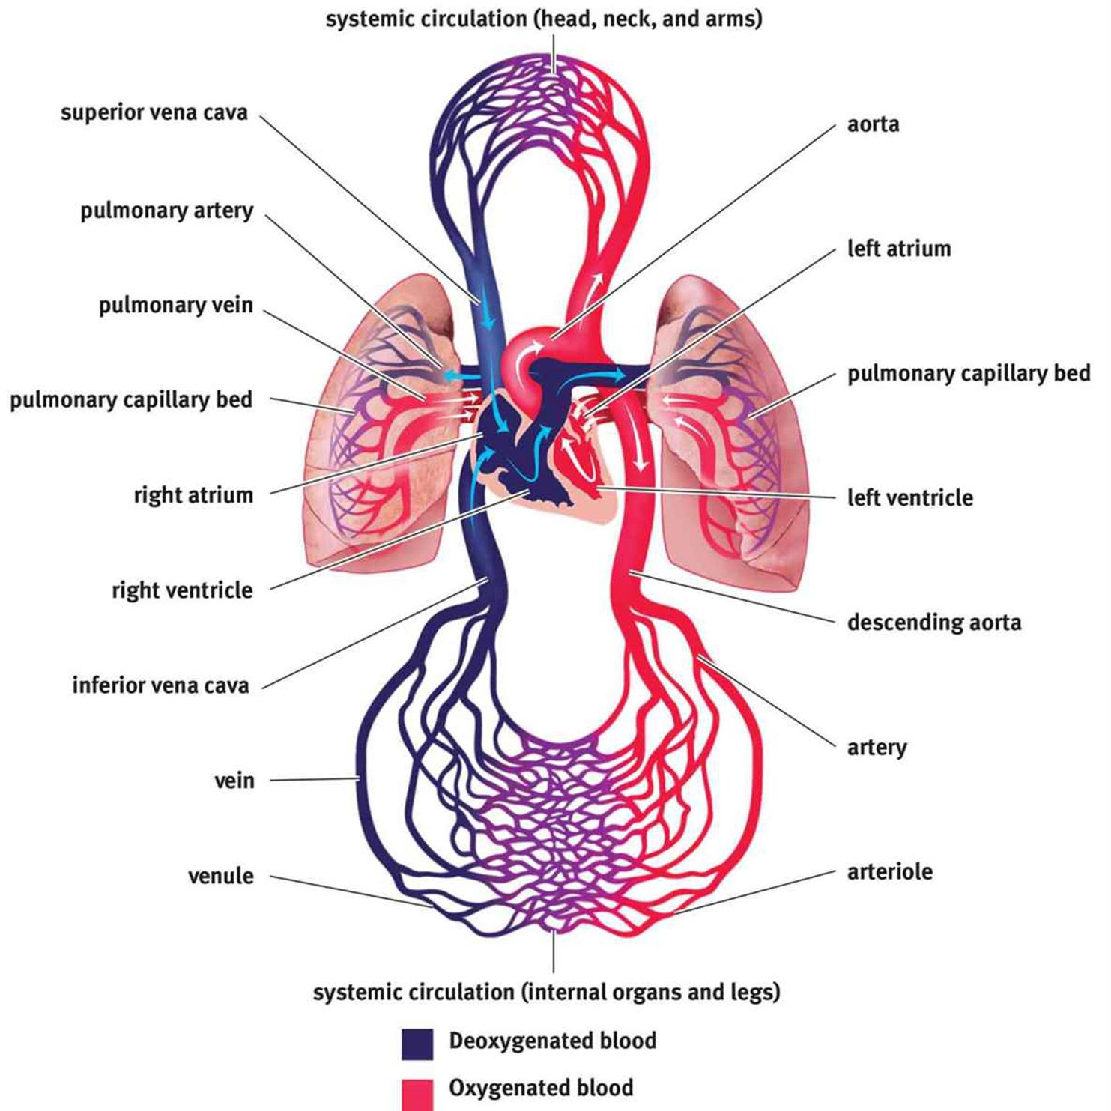

The Heart

* Composed of cardiac muscle and supports **pulmonary circulation** (lungs) and **systemic circulation** (rest of body)
* Blood flow: right atrium → (tricuspid valve) → right ventricle → (pulmonary valve) → pulmonary artery → lungs → pulmonary vein → left atrium → (bicuspid/mitral valve) → left ventricle → (aortic valve) → aorta → arteries → arterioles → capillaries → venules → veins → vena cava → right atrium

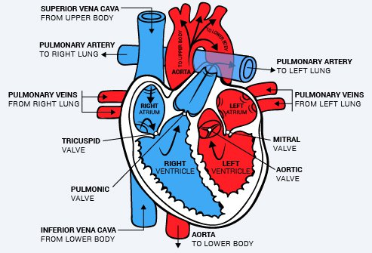

* Ventricles more muscular than veins
  + Allow for more powerful contractions through the rest of the cardiovascular system
* **Left heart more muscular than right heart**
  + Right heart supports the circulation to the lungs (shorter distance + prevent damage to lungs → less pressure)
  + Left heart supports systemic circulation (longer distance, so more pressure)
* Electrical conduction: the muscle cells are connected by intercalated cells → contains many **gap junctions** directly connecting the cytoplasm of adjacent cells → coordinated ventricular coordination

1. **Sinoatrial (SA) node** generates 60-100 beats per minute, even if all innervation to the heart is cut → myogenic activity
   1. Passive filling: Depolarization wave from SA node → two atria contract simultaneously
   2. Active filling: **Atrial systole (contraction)** → increased atrial pressure → forces more blood (atrial kick) into the ventricles (~5 - 30% of cardiac output)
2. **Atrioventricular (AV) node**
   1. Signal is delayed here → allow ventricles to fill completely before they contract
3. **Bundle of His** found in the interventricular septum (wall)
4. **Purkinje fibres**

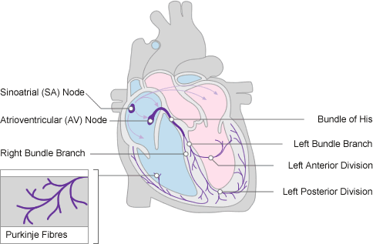

* Contraction
  + **Systole**: ventricular contraction when the AV valves are closed
  + **Diastole**: the heart is relaxed and SL valves are closed
  + **Cardiac Output (CO; L/min) = Heart Rate (HR; beats/min) x Stroke Volume (SV; L/beat)**

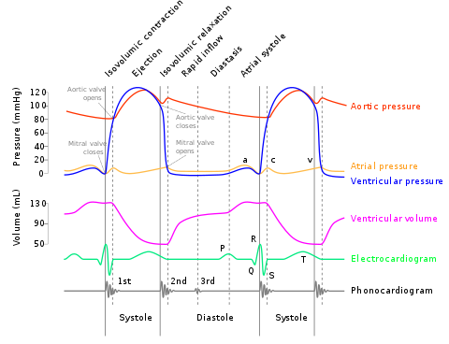

The Vasculature

* All blood vessels are lined with **endothelial cells**
  + Maintain the vessels by releasing chemicals that aid in vasodilation and vasoconstriction
  + Allow white blood cells to pass through the vessel wall and into the tissues during an inflammatory response
  + Release certain chemicals when damaged → necessary for formation of blood clots to repair the vessel → stop bleeding

1. Arteries (many smooth muscles, no valves)
   1. **Highly muscular and elastic** → creates tremendous resistance to the flow of blood → left heart must generate higher pressures
   2. Arteries filled with blood → **elastic recoil** from their walls to maintain a high pressure → forces the blood forward
2. Capillaries (no smooth muscles, no valves; interface b/w cardiovascular system and tissues)
   1. Single endothelial layer and small
      1. RBCs must pass through in a single file from arterioles to venules
      2. Easy **diffusion** of gases, nutrients, wastes, endocrine signals
   2. If damaged, blood leave the capillaries → enter the interstitial space → bruise (closed space)
3. Veins (little smooth muscles, contain valves)
   1. Inelastic, thin-walled structures → less recoil capability
      1. But still able to stretch → accommodate more blood
   2. Compressed by surrounding skeletal muscles and have **valves** to maintain **one-way flow**

Circulation

* In most cases, blood will pass through only **1** capillary bed before returning to the heart
  + However, there are 3 **portal systems**, in which blood will pass through **2** capillary beds in series before returning to the heart

Portal systems:

1. Hepatic portal system
   1. Blood leaving the capillary beds in the walls of the **gut** → blood capillary beds in the **liver**
2. Hypophyseal portal system
   1. Blood leaving the capillary beds in the **hypothalamus** → capillary beds in the **anterior pituitary** → paracrine secretion of releasing hormones
3. Renal portal system
   1. Blood leaving the **glomerulus** → efferent arteriole → capillary network (called **vasa recta**) surrounding the nephron

**7.2 Blood**

Composition

* Composed of cells and plasma, an aqueous mixture of nutrients, salts, respiratory gases, hormones and blood proteins
* **Erythrocytes** (RBCs) lack mitochondria, nucleus and organelles → make room for hemoglobin → carry oxygen
  + No nucleus → cannot divide → life span = 120 days → old RBCs phagocytized by liver and spleen
  + No mitochondria → no oxidative phosphorylation to generate ATP (i.e. cannot metabolize the oxygen before it reaches the peripheral tissues) → relies completely on glycolysis (in the cytoplasm) for ATP → will produce lactic acid
  + Biconcave shape → squeeze through tiny capillaries + increase cell surface area for more gas exchange
  + Measurements: hemoglobin concentration and **hematocrit** (% of RBCs in blood)
* **Leukocytes** (WBCs) are formed in the bone marrow
  + Non-specific immunity
    - Neutrophils, eosinophils, basophils
    - Monocytes (which will be renamed **phagocytes** once they leave the bloodstream)
      * CNS: Microglia
      * Skin: Langerhans cells
      * Bone: Osteoclasts
  + Specific immunity
    - B and T cells
* **Thrombocytes** (platelets) are cell fragments from megakaryocytes
  + Coagulation + blood clotting

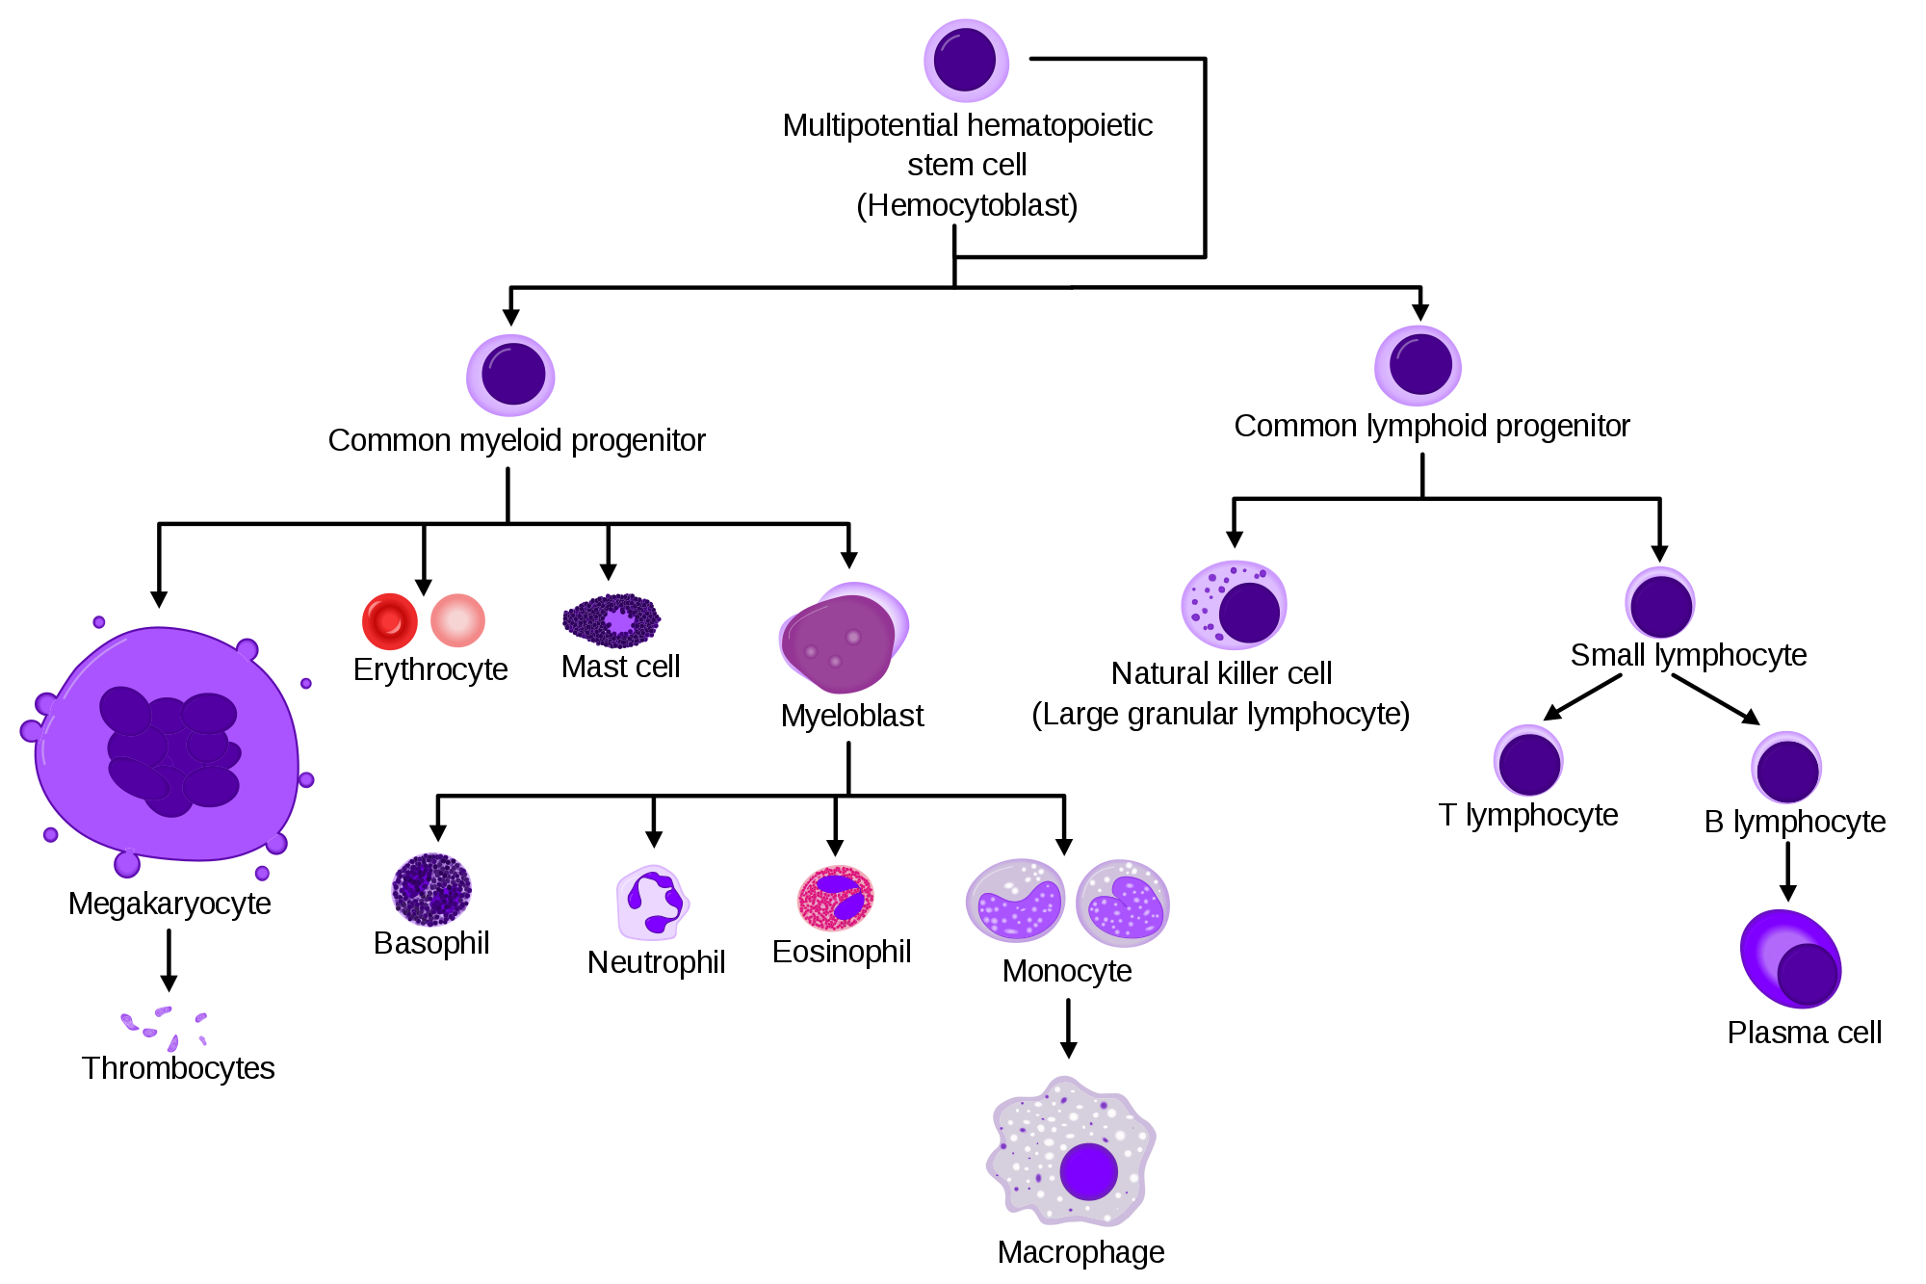

Blood Antigens

* ABO antigens
  + A and B are codominant, O is recessive
  + The receiver’s blood cells must not produce antibodies that will lyse the donor’s blood cells

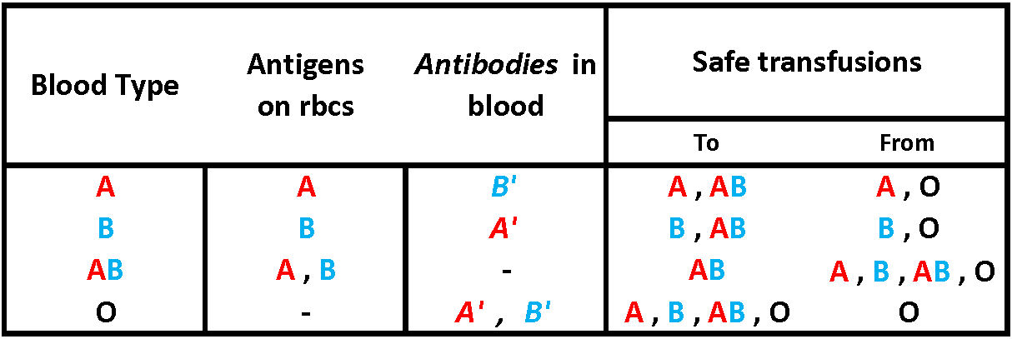

* Rhesus factor (Rh- is recessive)
  + Rh- mother gets pregnant with first Rh+ child
  + During **pregnancy**, Rh- mother is exposed to fetal blood (rmb blood do not cross the placenta) → starts making antibodies
  + First Rh+ child is already born by the time Rh- mother produces anti-Rh antibodies → mother is sensitized to the Rh factor
  + If Rh- mother is pregnant again with a second Rh+ child, the anti-Rh antibodies will cross the placenta and attack the fetus
  + This is called **erythroblastosis fetalis**

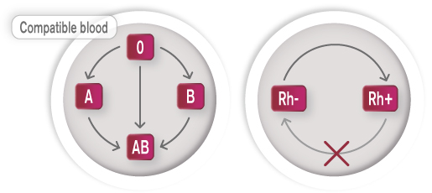

**7.3 Physiology of the Cardiovascular System**

Blood Pressure

* Force per unit area that is exerted on the walls of the blood vessels by blood, measured using **sphygmomanometer**
* Divided into systolic and diastolic components
* Must be high enough to overcome the resistance created by the arterioles and capillaries, but low enough to avoid damaging the vasculature and surrounding structures
  + Capillary beds increase surface area → it’s like adding resistors in a parallel branch → decrease vascular resistance
* Blood Pressure (maintained by baroreceptor and chemoreceptor)
  + Low BP → promotes aldosterone and ADH release
    - High blood osmolarity → promotes ADH release
  + High BP → promotes ANP release

Gas and Solute Exchange

* Occurs at the level of capillaries and relies on concentration gradients to facilitate diffusion. Capillaries are also leaky.
* Two Starling forces:
  + Hydrostatic pressure: the pressure of the fluid within the blood vessel → forces fluid out at the arteriolar end of a capillary bed
  + Osmotic pressure: the “sucking” pressure drawing toward solutes
    - Oncotic pressure: osmotic pressure due to proteins → draws fluid back in at the venule end
* Oxygen is carried by the hemoglobin, which exhibits **cooperative binding**
  + In the lungs: High P.P (100mmHg) of O2 → loading of O2 onto hemoglobin
  + In the tissues: Low P.P (40 mmHg) of O2 → unloading O2 into tissues (~20%)
  + 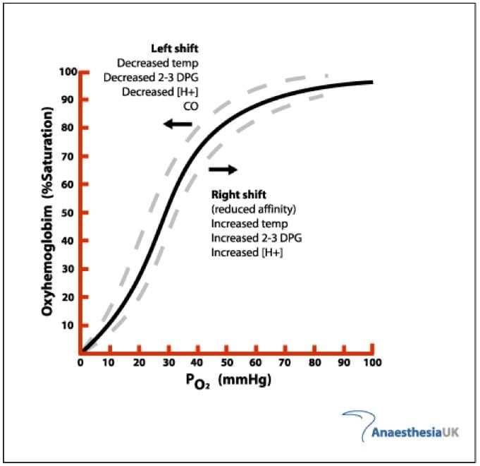
  + Take note that the left shift can also be seen in fetal hemoglobin compared to adult hemoglobin → fetal requires higher affinity for oxygen
* Nutrients, wastes, and hormones are carried in the bloodstream to tissues for use or disposal

Coagulation

* When the endothelial lining of a blood vessel is damaged, the collagen and tissue factor underlying the endothelial cells are exposed → coagulation cascade
  + Endpoint
    - Activation of prothrombin to **thrombin** by thromboplastin
    - Thrombin then converts fibrinogen to **fibrin**
    - Fibrin forms small fibres that aggregate and cross-link like a net to capture RBCs and other platelets → forms a clot (scab) over the damaged area
  + Clot is ultimately broken by **plasmin**, which is generated from plasminogen

